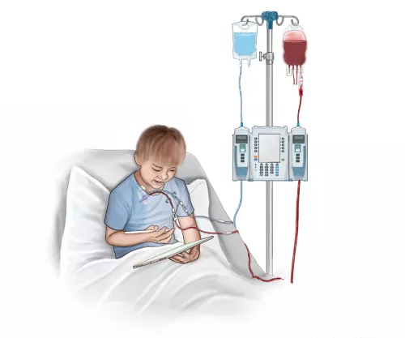
BLOODLINK
INSTRUCTOR: NISAR SIDDIQUE
SUNEEL KUMAR , BAQAR ALI | 9/23/26 | WEB ENGINEERING

Contents
1. Introduction 1
2. Problem Statement 1
3. How the Project Works (Methodology) 2
3.1 Architecture & Technology Stack 2
3.2 Core Workflow & Implementation Flow 2
4. Major Outcomes 3
5. Conclusion 3

BloodLink

1. Introduction
Modern medical emergencies demand rapid, precise coordination between hospitals, patients, and blood donors. Traditional methods of sourcing blood—such as forwarding unverified requests across social media groups or relying on fragmented word-of-mouth—frequently result in severe information decay, duplicate efforts, and panic fatigue.
BloodLink is a centralized, full-stack web application engineered to solve this critical communication bottleneck. By providing a structured, searchable digital directory of verified local blood donors and real-time emergency broadcast logs, BloodLink bridges the gap between those in urgent need of life-saving plasma and eligible community members ready to assist.

2. Problem Statement
The current ecosystem for managing emergency blood requests suffers from several critical operational friction points:
- Information Decay & Spam: Broadcast messages on instant messaging platforms quickly become outdated, leading people to call numbers for patients who have already received blood or passed away.
- Lack of Granular Filtering: Finding a specific rare blood type (e.g., $O-$ or $AB-$) within a specific neighborhood or city zone is cumbersome using general social media feeds.
- Absence of Donor State Tracking: Existing directories rarely track whether a registered donor is currently medically eligible (e.g., adhering to the mandatory 3-month gap between donations) or currently available.
- Privacy Vulnerabilities: Exposing raw donor contact details publicly on static lists leaves individuals vulnerable to spam and privacy breaches.

3. How the Project Works (Methodology)
BloodLink operates on a classic Client-Server Architecture, utilizing a decoupled frontend interface that communicates with a RESTful backend API connected to a persistent database.

3.1 Architecture & Technology Stack
- Frontend (Client Side): Built using HTML5, CSS3, and Vanilla JavaScript. It handles user interactions, client-side form validations, instant UI filtering, and asynchronous server communication via the Fetch API.
- Backend (Server Side): Built using Node.js and Express.js to manage incoming HTTP requests, process business logic, and construct secure database queries.
- Database (Persistence Layer): A relational database (MySQL or MongoDB) configured to store structured user profiles, donor status logs, and active emergency requirements.

3.2 Core Workflow & Implementation Flow
- Donor Registration & Eligibility Validation:
  - A user submits their details via the registration form (Name, Blood Group, City Zone, Phone Number, and Last Donation Date).
  - JavaScript calculates the time elapsed since the last donation. If it is less than 3 months, the system flags the user as ineligible to ensure medical safety standards are met.
- Dynamic Search & Filtering:
  - Users utilize interactive dropdown filters on the dashboard to query donors by specific blood groups and city zones.
  - Event listeners in JavaScript capture these inputs and send a GET request with query parameters to the Express backend.
  - The backend executes a secure parameterized query, returning matching records as a JSON payload, which the frontend dynamically renders into clean UI cards.
- Emergency Broadcast Management:
  - When an urgent medical need arises, a user posts an emergency request detailing the patient name, hospital, units required, and contact person.
  - This instantly updates the database and populates a high-visibility, real-time alert banner at the top of the application dashboard.
- Privacy Protection (Data Masking):
  - To safeguard user privacy, sensitive phone numbers are dynamically masked on public directory lists (displaying truncated digits), preventing unsolicited harvesting of personal data.

4. Major Outcomes
The successful implementation of BloodLink achieves the following technical and social milestones:
- Centralized Data Persistence: Established a fully functional CRUD (Create, Read, Update, Delete) database structure capable of managing live donor accounts and emergency requests without data loss.
- Responsive User Interface: Developed a mobile-first, high-contrast medical interface that ensures usability for users accessing the platform under stressful conditions via smartphones.
- Efficient Client-Server Communication: Implemented asynchronous Fetch API calls that allow users to search and filter large sets of local records instantly without triggering full-page reloads.
- Impact-Driven Problem Solving: Replaced chaotic, unverified messaging loops with a structured, searchable utility that drastically reduces search time during critical medical emergencies.

5. Conclusion
BloodLink successfully demonstrates the core principles of Web Engineering by turning a complex real-world crisis into a structured, responsive, and secure digital solution. By combining clean database architecture, robust backend routing, and dynamic frontend interaction, the project proves that lightweight web applications can solve high-stakes community problems efficiently. Future enhancements—such as integrating automated SMS/WhatsApp APIs (e.g., Twilio) for instant emergency notifications and implementing Role-Based Access Control (RBAC) for hospital verification—will further scale BloodLink into a fully deployable health-tech platform.

